1. Northwest has the most associated salespeople. There are 3 of them and they are: Ansman-Wolfe, Pamela; Campbell, David; Mensa-Annan, Tete. I selected all territories and compared how many associated salespeople each territory had.

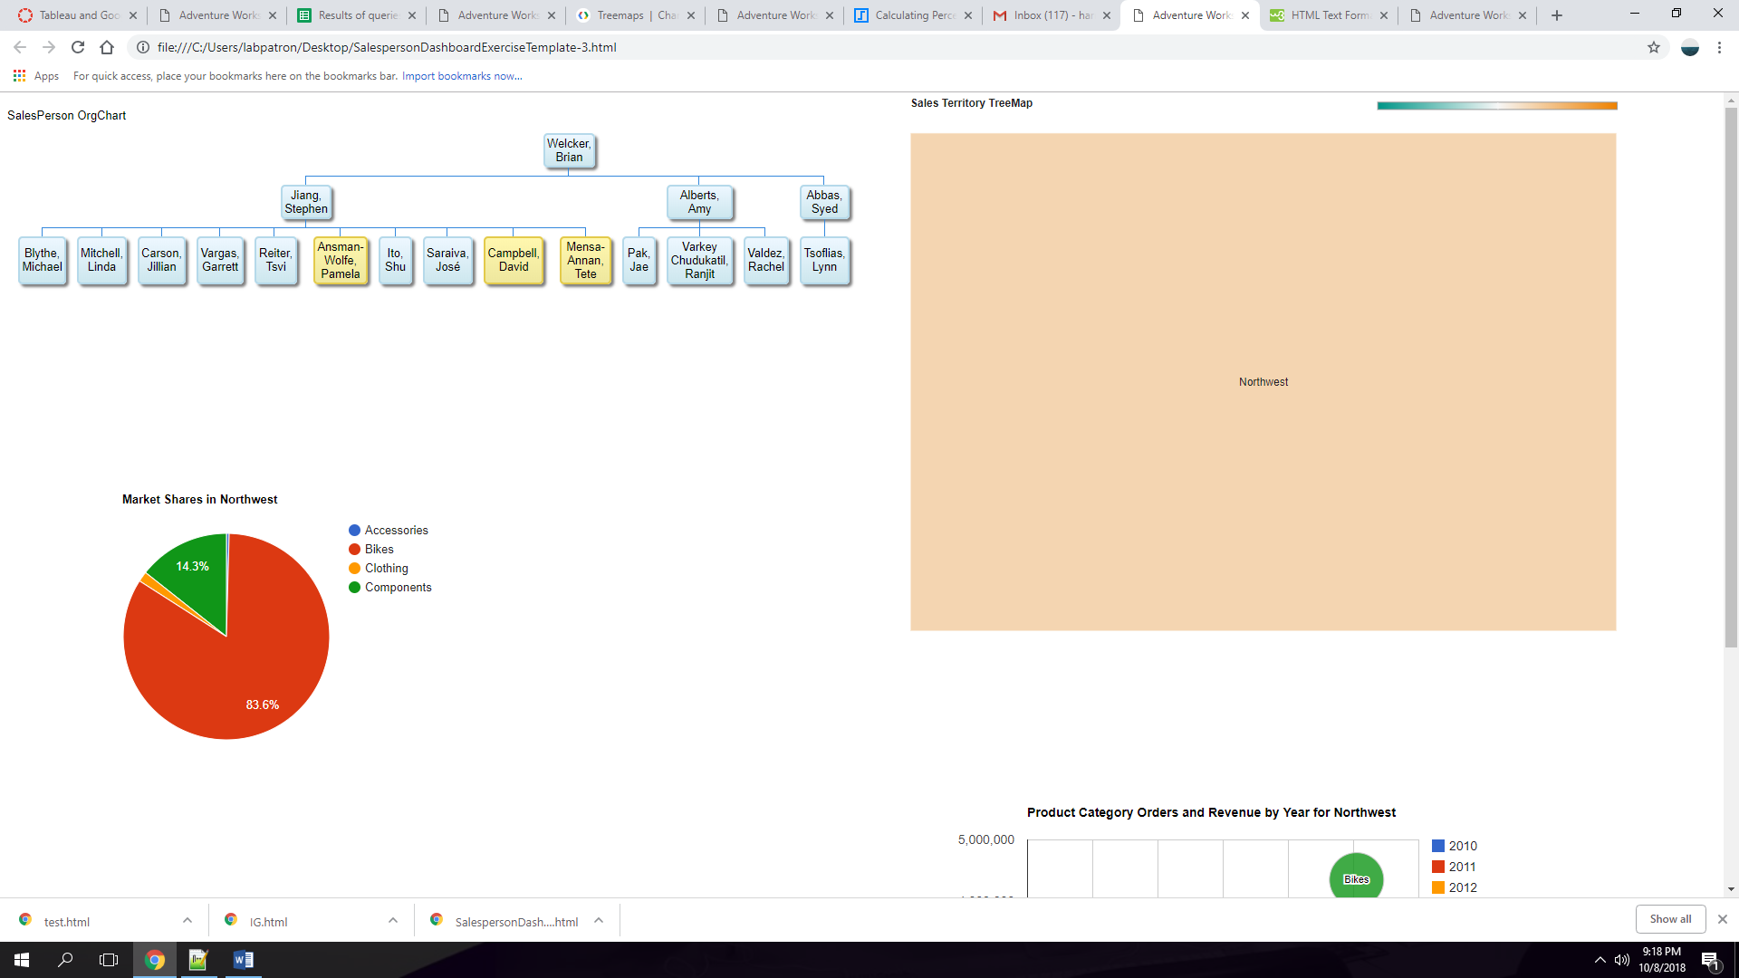

1. 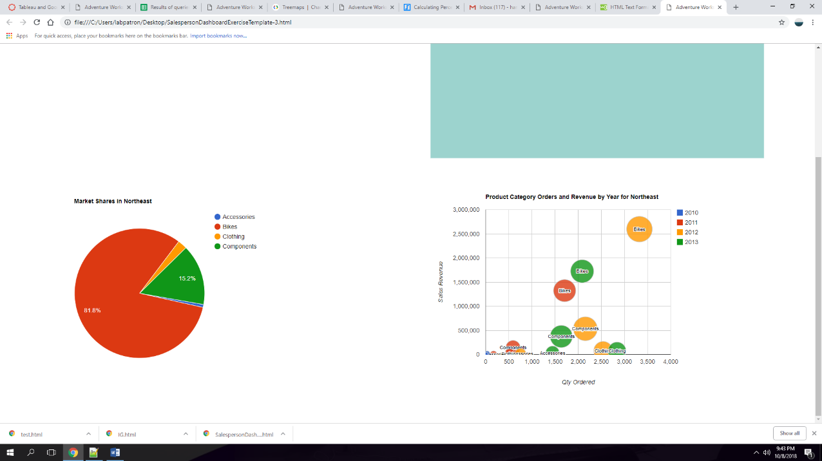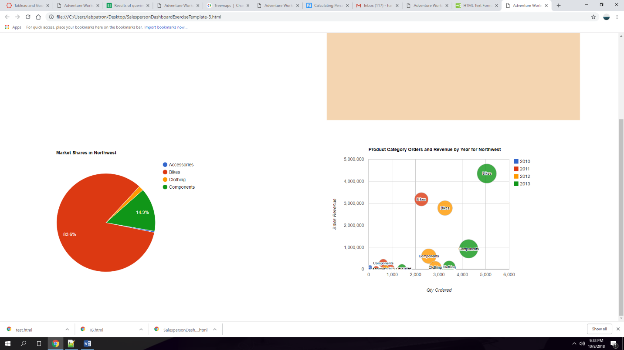Southwest(2012-2013); Northwest(2011-2012); Northeast(2012-2013); Southeast(2011-2012); Canada(2012-2013).

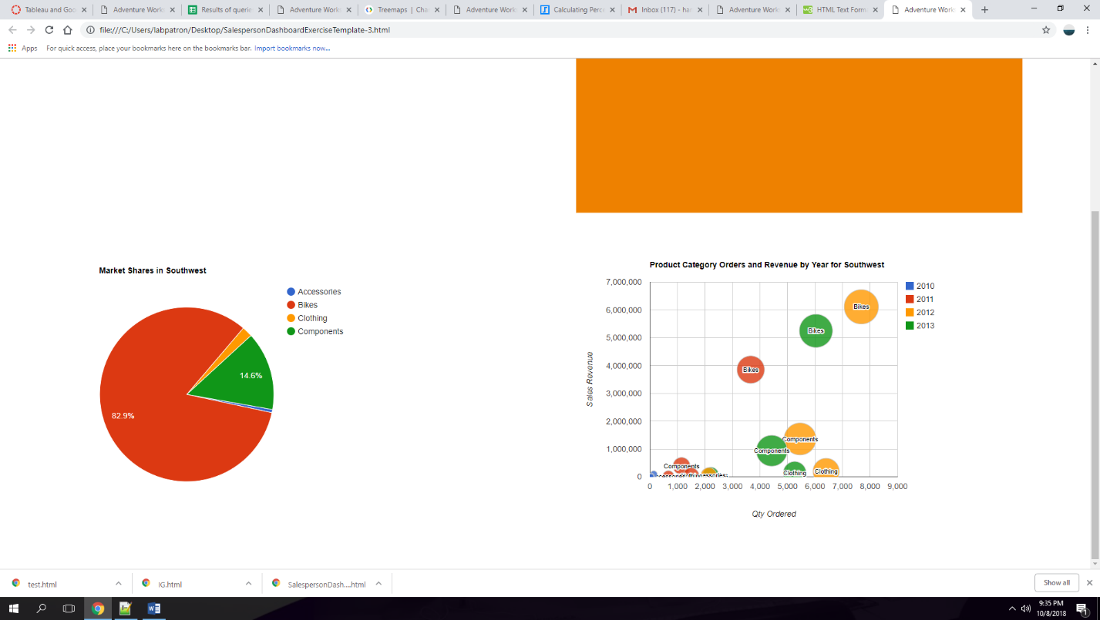

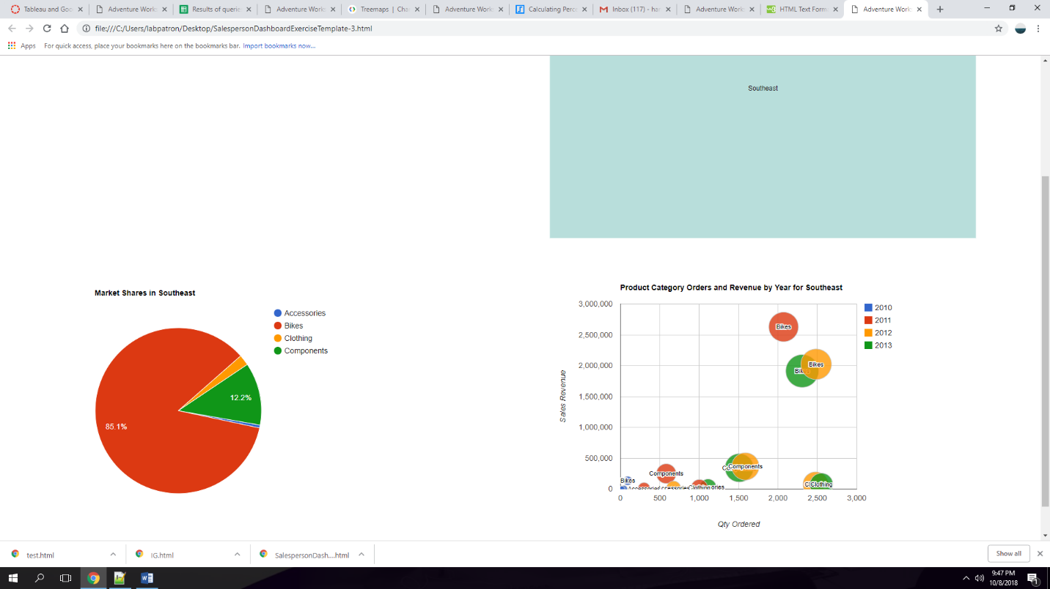

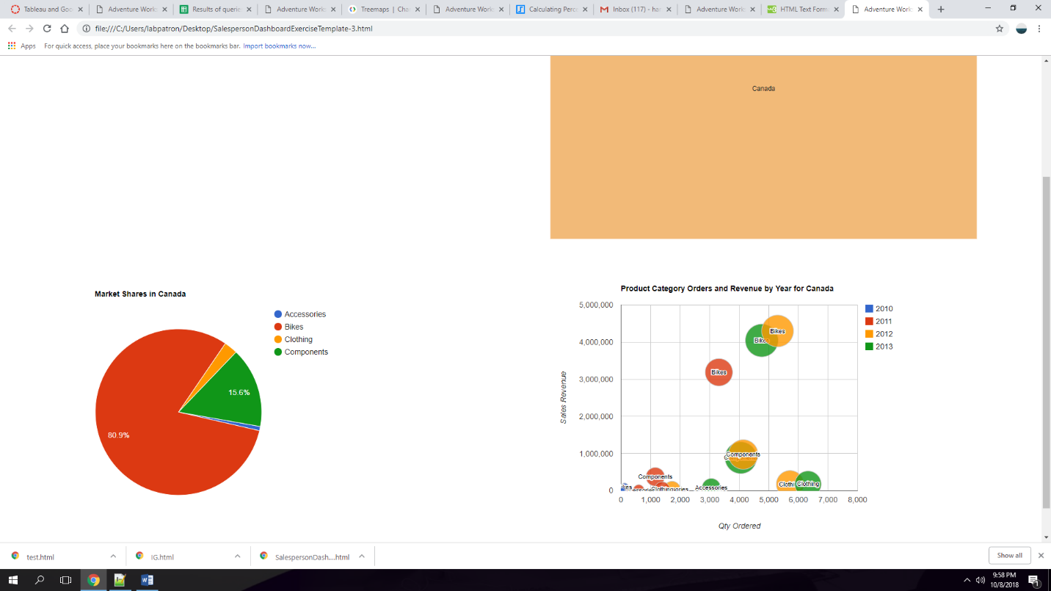

3) There are two cases where one sales territory has more orders but less revenue than another. Northeast and Central; Northeast and Southwest. I hovered the mouse over territories on the treemap and compared their orders and sales to one another.

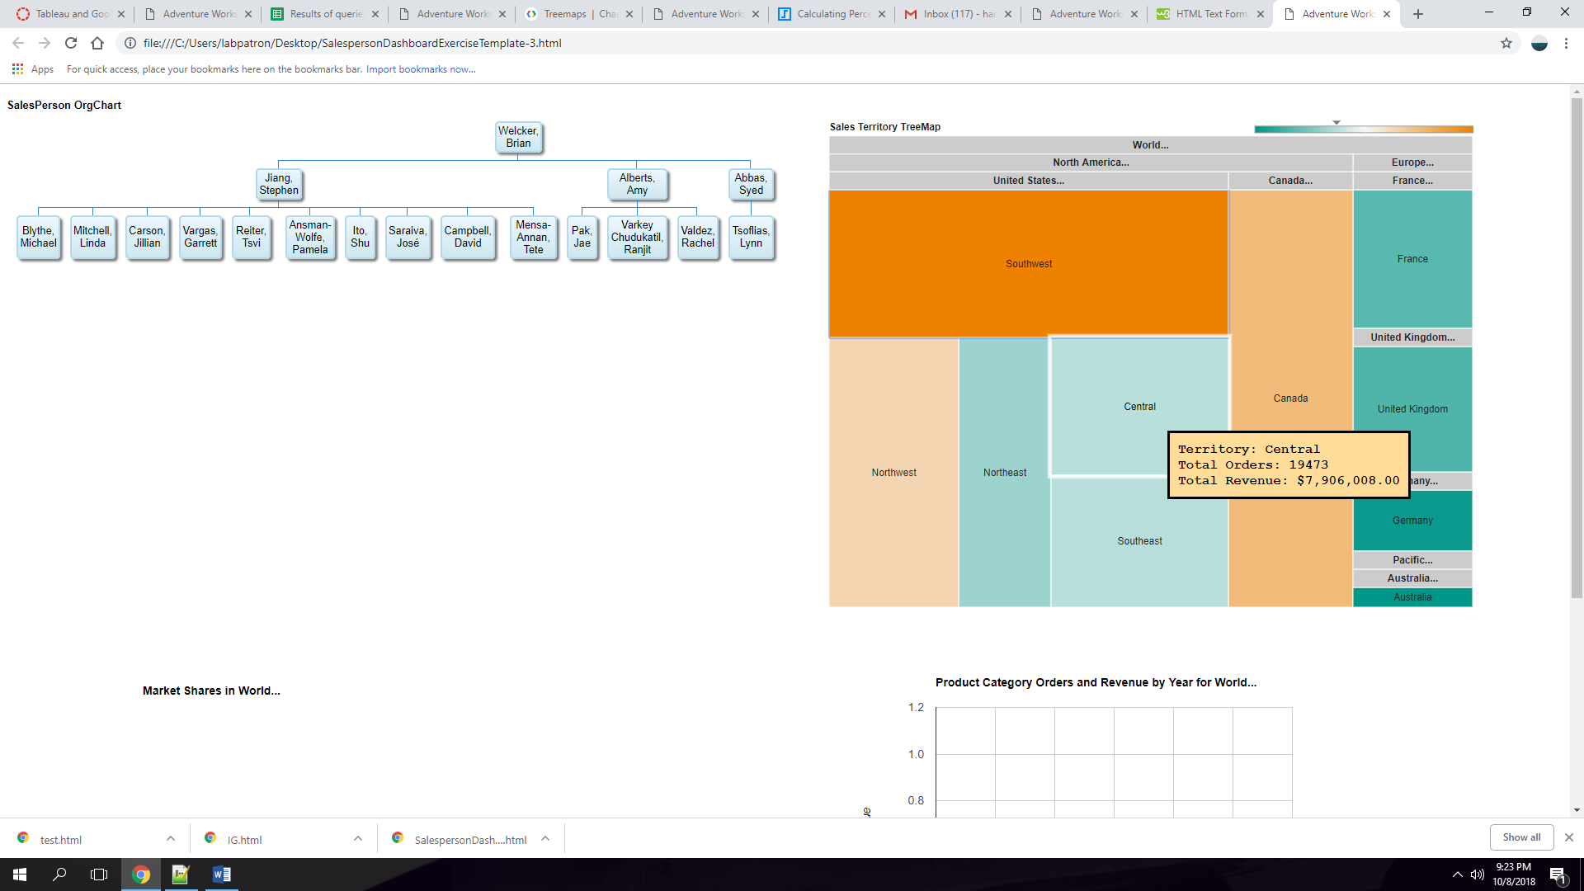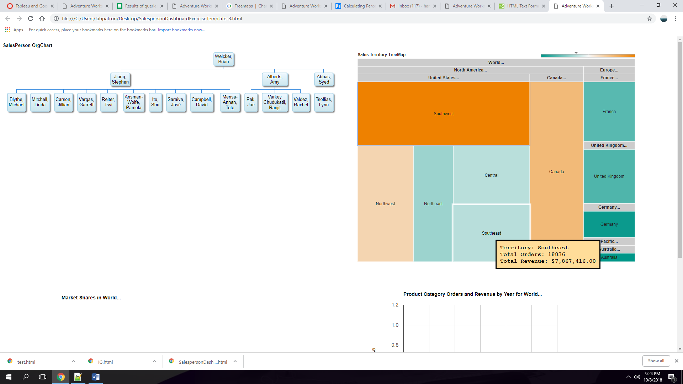

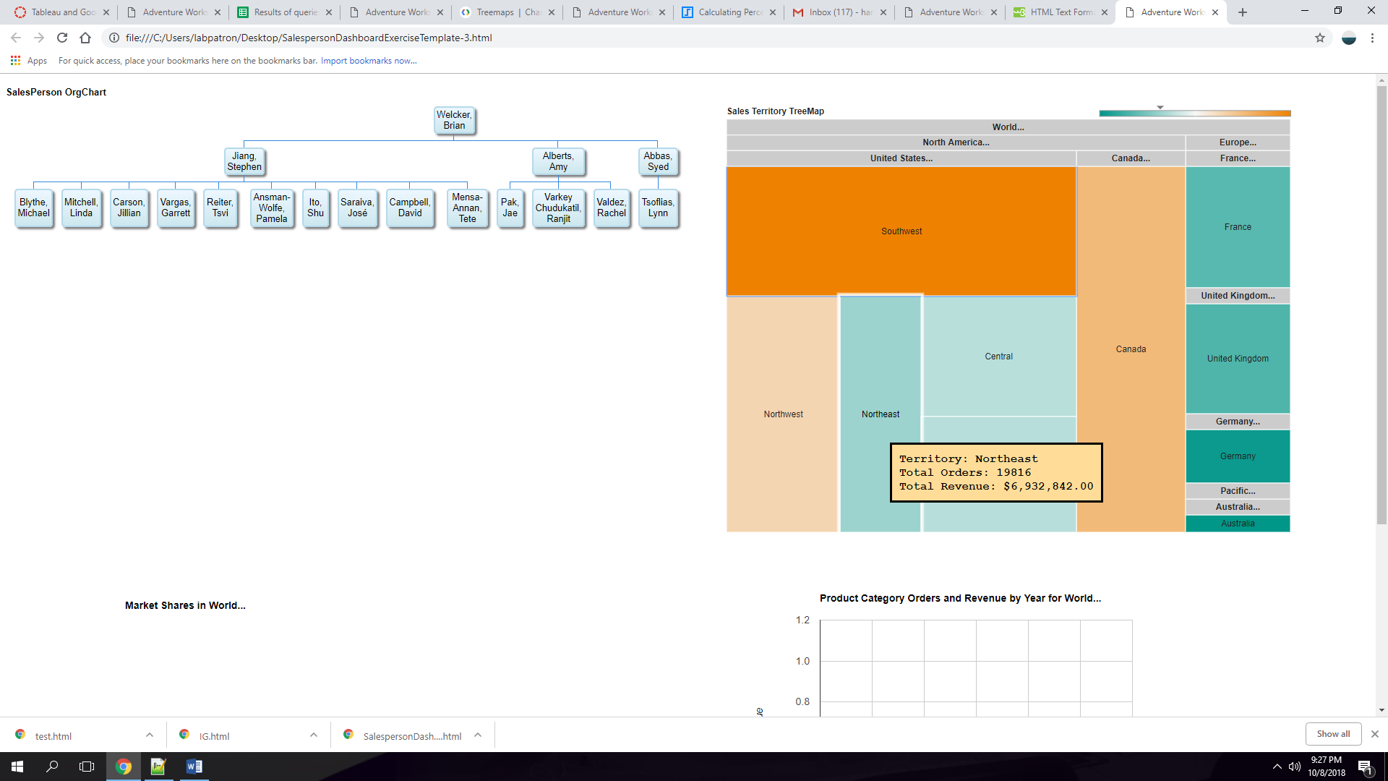

1. As you can see on the google visualization the Bike market has the most significant growth in sales. For that reason I didn’t look at other markets sales. Those markets are Southwest, Northwest, Northeast, Central, France, UK, Germany, Australia, Canada. I selected territories and looked for the highest sales amount for different markets.

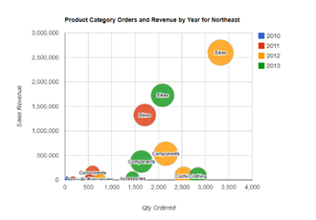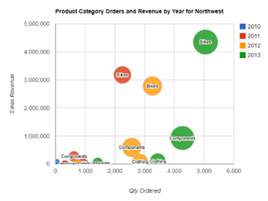

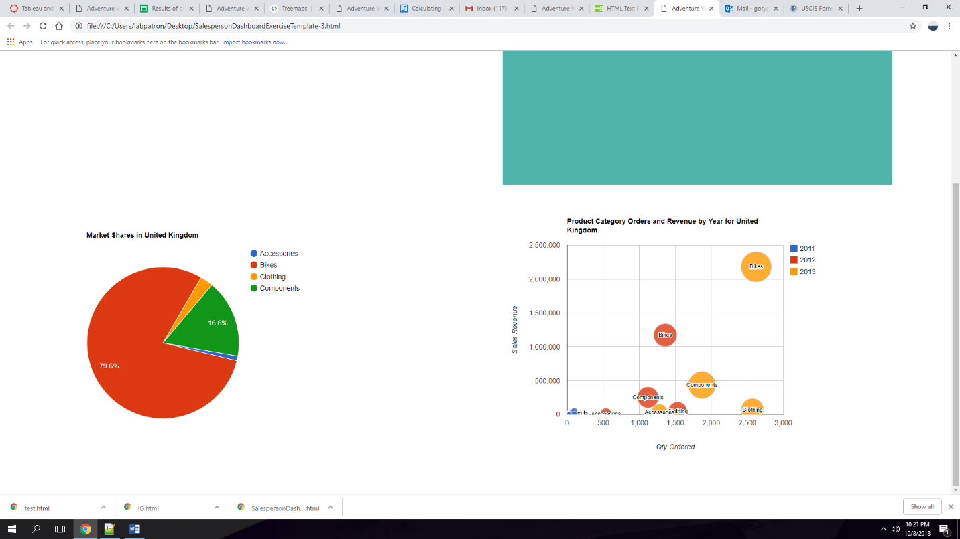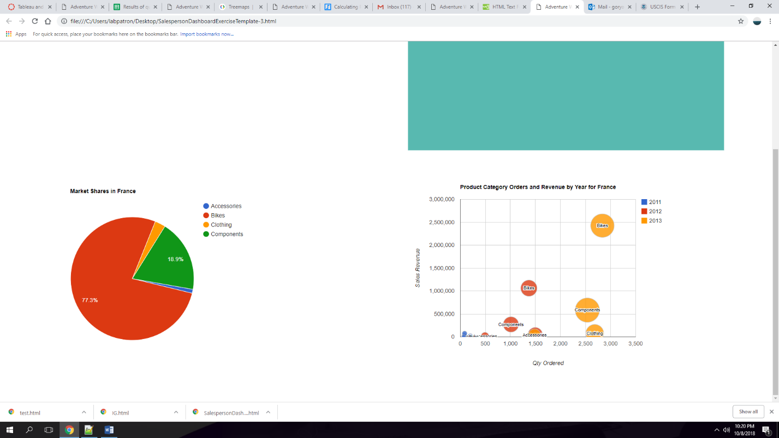

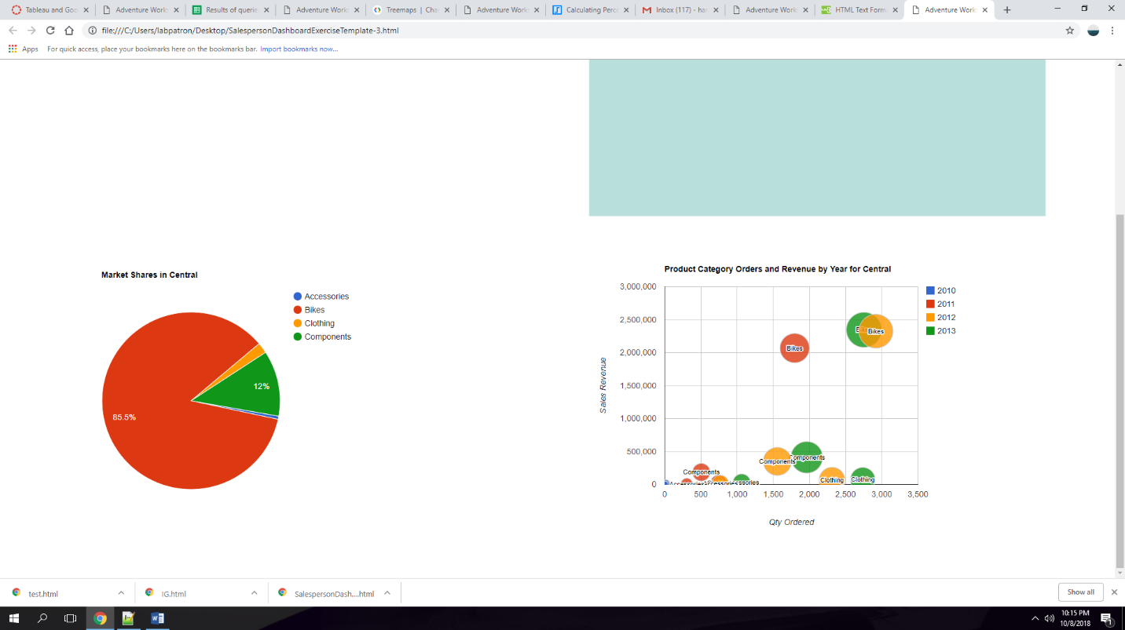

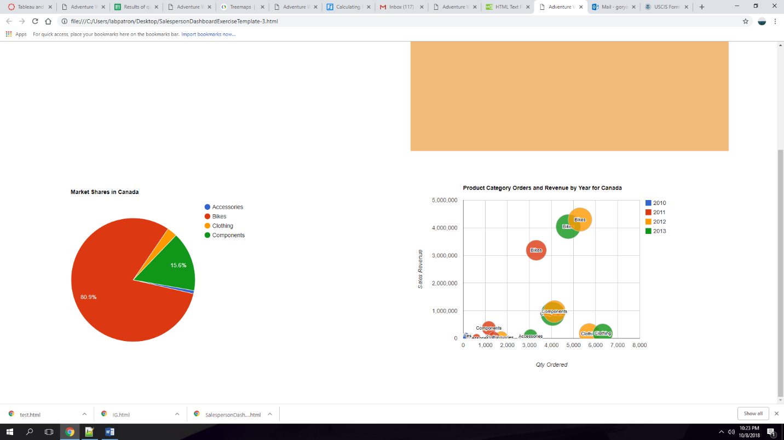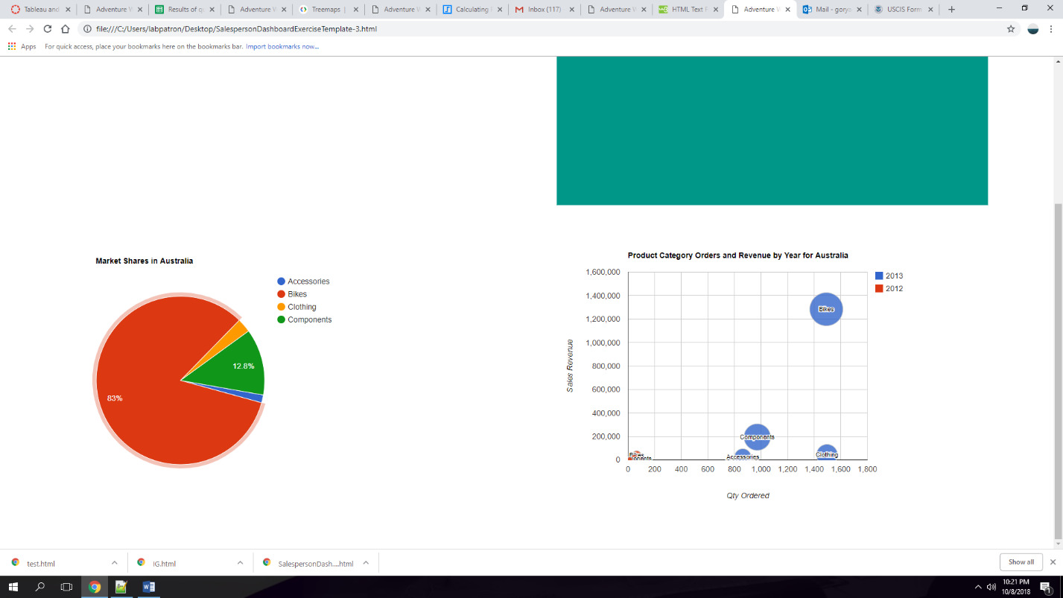

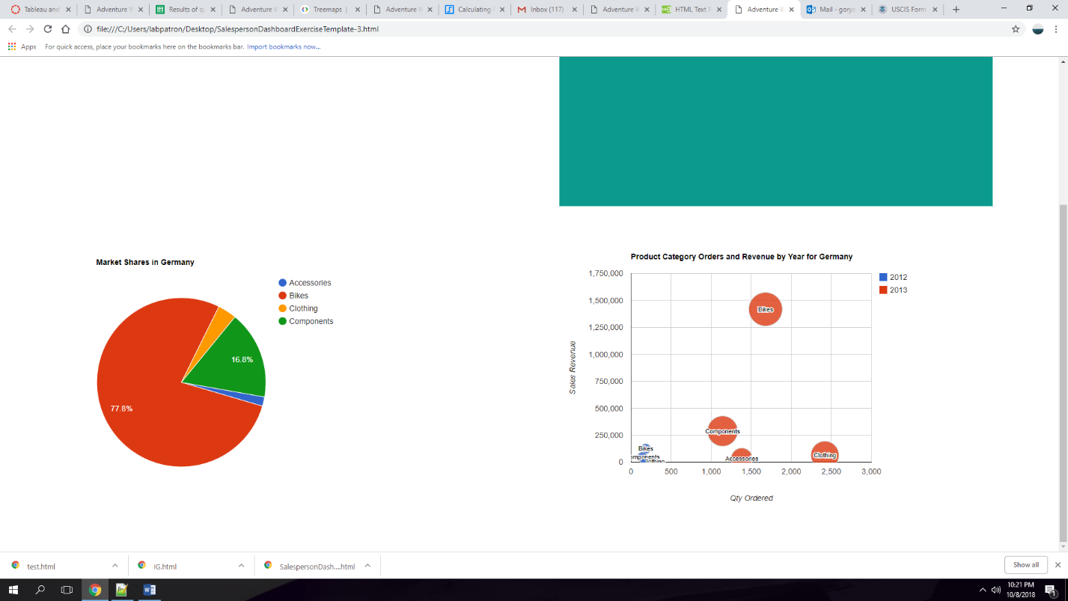

1. Which markets have the highest market share? My Pie chart shows the selected territory with its respective Market Shares.

